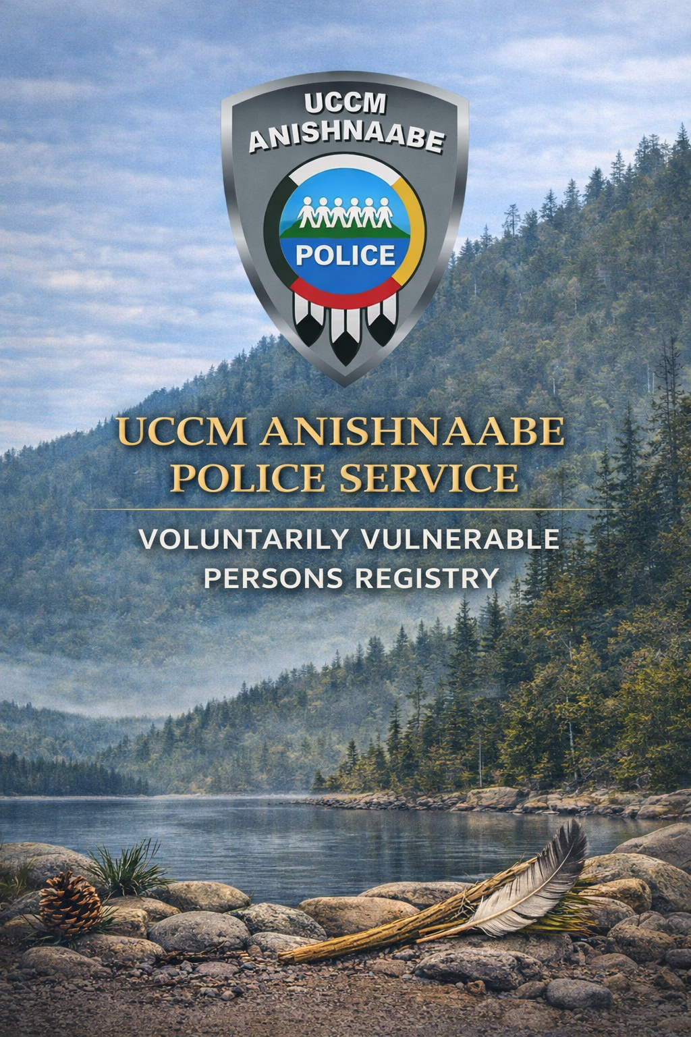

TERMS & CONDITIONS – VOLUNTARY VULNERABLE PERSONS REGISTRY
The Voluntary Vulnerable Persons Registry is a program being offered by the UCCM Anishnaabe Police Service with implementation supports from community partners.
The registry assists police in providing a coordinated response when a vulnerable person goes missing, is susceptible to misadventure or is at an increased risk in a crisis situation. The registry can be used to provide support for people who are at a greater risk during emergencies, disasters or crisis due to cognitive, physical or intellectual/developmental disabilities.
The Voluntary Vulnerable Persons Registry is an investigative tool. It is a database utilized to expedite important information when an emergency arises. It does not provide supervision or any other form of care to vulnerable persons.

DEFINITION OF A VULNERABLE PERSON
The definition of a vulnerable person for the purposes of this registry is:
- A person who has a cognitive, physical, intellectual or developmental disability or other condition(s) which may place an individual at an increased risk of misadventure leading to injury or death, and who may require assistance from emergency services.

COMPLETING THE APPLICATION FORM:
Pleas ensure to complete the application in full, as well as ensuring the application is signed and witnesses. You must attach a recent coloured photograph, showing a full-frontal view of the individuals face and shoulders. Please ensure the photograph is clear, sharp, in focus and taken against a neutral background. Electronic submission is preferred; however printed copies are accepted.
PLEASE NOTE:
- The application will be returned if not completed in full or if the requested photograph does not meet the requirements outlined above.
- It is your responsibility to renew the application. Renewal is every two years on the individual’s birthdate.
- If the individual is under the age of 16 years, a renewal will be required annually.
- Please ensure all information provided is accurate and up to date.
For additional information or questions please contact the Social Navigator via email at jewel.sanftenberg@uccmpolice.com or by phone at (705) 377-7135.

PRIVACY – ACCESS, COLLECTION & USE OF INFORMATION
The information contained in the application and database is confidential and privileged information. The information collected in the form is personal information (including but not limited to name, contact information, physical and behavioural characteristics and traits) as defined by applicable privacy legislation (for the UCCM Anishnaabe Police Service that means the Personal Information Protection and Electronic Documents Act (PIPEDA)
The information is intended for the use of UCCM Anishnaabe Police Service and any other agency(s) or person that the UCCM Anishnaabe Police Service feels will assist in aiding the vulnerable person or this program. Therefore, this information may be disseminated, distributed, copied or conveyed by the UCCM Anishnaabe Police Service to any other accredited police or health care agency involved in providing care of an emergent nature or under circumstances; in which the best interests of the vulnerable person, requires such communication so as to expedite assistance by both policing and medical authorities. However, those agencies or persons will be required to use the information only for those purposes and otherwise keep confidential in accordance with the applicable privacy laws in Ontario/Canada.

Privacy Questions or concerns may be directed to:
UCCM Anishnaabe Police Service’s Chief of Police - James Killeen
james.killeen@uccmpolice.com
5926 Highway 540, M’Chigeeng, ON P0P 2E0
Phone: (705) 377-7135
Fax: (705) 377-5583
www.uccmpolice.com

TERMS, CONDITIONS & ACKNOWLEDGEMENTS
It is acknowledged by all that I (or my guardian/legal representative with lawful authority) retains the right to modify this information or cancel my authorization for the implementation and maintenance of this information file at any time by way of written notice delivered personally or by my guardian/legal representative.
I/my legal guardian or legal representative agrees to provide a current photograph of the vulnerable person, and an accurate and completed application form.
I/my legal guardian or legal representative agrees to notify the administrators of the registration and database information of any changes in the information submitted and to provide an updated application as per the timeline outlined.
I/my legal guardian or legal representative certifies that the information above is true and correct.

For legal guardians or legal representatives, I have:
- Obtained the permission and consent of the vulnerable person to apply on their behalf;
- The legal authority to apply on behalf of the vulnerable person because:
- The vulnerable person is under the age of 16 years old;
- I have a valid and unrevoked authorization or Power of Attorney for Personal Care that was made when the vulnerable person had legal capacity which gives me authority AND the vulnerable person has been deemed lacking capacity by a court or licenced physician/assessor;
- I have the court’s authorization/appointment or other legal authority pursuant to legislation in Ontario (e.g. Public Guardian and Trustee).

RELEASE/INDEMNITY
In consideration of the UCCM Anishnaabe Police Service’s compliance with the collection, use and disclosure as set out above, I release, waive and forever discharge the UCCM Anishnaabe Police Services Board, it’s officers, employees and agents, and other law enforcement or health care agencies, the partners assisting or supporting this initiative and administrators of the website and database from all claims, demands, damages, costs, expenses, actions, causes of action, whether in law or equity, resulting or alleged to result from your compliance with the foregoing authorization. I further waive any and all rights I may now or in the future have with respect to any disclosure of the personal information collected.
I agree and acknowledge that this is a completely voluntary sharing of information in the best interests of safety for the vulnerable person. This is to mitigate risk of harm but in no way guarantees safety or protects the vulnerable person and/or you from being accountable for criminal activity or civil liability.

Please write/sign your initials in the box below to indicate that you have read the Terms and Conditions or that they have been read and explained to you.

Initials

Voluntary Vulnerable Persons Registry Application

Please complete this application as neatly and accurately as possible.

PERSONAL DATA:

Last Name:_________________________________ Given Name(s):____________________________
Nickname/Preferred Name:________________________________
Gender: Male Female Transgender Non-Binary
Date of Birth:____________________________________ Age:___________________

HOME ADDRESS:
Street Address:__________________________________________________________________________________
City:_______________________________ Province:___________________ Postal Code:_______________
Home Phone:_______________________________ Work Phone:____________________________________
Cell Phone:_________________________________ Cell Phone Provider:_____________________________

WORK/SCHOOL:
Employer/School:_________________________________ Contact Information:________________________
Address:_________________________________________________________________________________________

PHYSICAL CHARACHERISTICS:
Height:___________________ Weight__________________ Build:_________________________________
Complexion:___________________ Hair Colour:________________ Style/Length:_____________________
Facial Hair:____________________ Facial Hair Colour:______________ Eye Colour:__________________
Glasses/Contact Lenses:_____________________
Please describe any Marks, Scars, Tattoos, etc. including location on the body:
____________________________________________________________________________________________________________________________________________________________________________________________________________________________________________________________________________________________________________________________________________________________________________________________________

COMMUNICATION CHARACTERISTICS:
Method of Communication:______________________________________________________________________
(Verbal, non-verbal, stutter, soft spoken, loud, repeats others, etc.)
Comprehension:_________________________________________________________________________________
(Age appropriate, will agree or disagree to something even if not fully understood, takes a while to respond, won’t ask for clarification, etc.)
Language(s):_____________________________________________________________________________________

NEEDS OF APPLICANT – PLEASE CHECK ALL THAT APPLY
Serious Mental Illness or Addiction Specify:____________________________________________________
Deaf, Deafened or Hard of Hearing Specify:____________________________________________________
Developmental/Intellectual/Cognitive Disability (Autism Spectrum Disorder, Downs Syndrome, FASD, Alzheimer’s, etc.)
Specify:__________________________________________________________________________________________
Vision Specify:_______________________________________________________________________________
Other Specify:_______________________________________________________________________________

Does the Vulnerable Person have any life threatening medical concerns or symptoms that can be mistaken for something else?______________________________________________________________________ __________________________________________________________________________________________________________________________________________________________________________________________________

Does the Vulnerable Person have a favourite pet? Please describe and include the pet’s names.
__________________________________________________________________________________________________________________________________________________________________________________________________

What is the best method for approaching the Vulnerable Person in situations and what de-escalation techniques work best? What helps the Vulnerable Person feel calm and safe?
____________________________________________________________________________________________________________________________________________________________________________________________________________________________________________________________________________________________________________________________________________________________________________________________________
Has the Vulnerable Person interacted with emergency services personnel (police, fire, paramedics)? What was your/their experience like? Please note actions/reactions if possible.
____________________________________________________________________________________________________________________________________________________________________________________________________________________________________________________________________________________________________________________________________________________________________________________________________

OTHER:
Does the Vulnerable Person wear or carry and identification?________________________________________
Does the Vulnerable Person have any inclination for running to/wandering to certain things or areas? Does the Vulnerable Person have favourite attractions and/or locations where you/they may be found?
____________________________________________________________________________________________________________________________________________________________________________________________________________________________________________________________________________________________________________________________________________________________________________________________________
Please provide any other relevant information:
_____________________________________________________________________________________________________________________________________________________________________________________________________________________________________________________________________________________________________________________________________________________________________________________________________________________________________________________________________________________________________
EMERGENCY CONTACT INFORMATION
The emergency contacts are people you want us to contact in cases of contact with Police. These are people who know, care and support you.

PRIMARY EMERGENCY CONTACT
First Name:___________________________________ Last Name:_____________________________________
Relationship to Vulnerable Person:_______________________________________________________________
Primary Phone Number:________________________ Secondary Phone Number:______________________
Email Address:__________________________________________________________________________________

SECONDARY EMERGENCY CONTACT
First Name:___________________________________ Last Name:_____________________________________
Relationship to Vulnerable Person:_______________________________________________________________
Primary Phone Number:________________________ Secondary Phone Number:______________________
Email Address:__________________________________________________________________________________

LEGAL GUARDIAN INFORMATION (IF APPLICABLE)
First Name:___________________________________ Last Name:_____________________________________
Relationship to Vulnerable Person:_______________________________________________________________
Address:________________________________________________ Unit/Apt. Number:_____________________
City/Town:________________________________ Province:____________ Postal Code:___________________
Primary Phone Number:________________________ Secondary Phone Number:______________________
Email Address:__________________________________________________________________________________
Type of Documentation Provided:________________________________________________________________

MEDICAL & DENTAL
Family Physician:__________________________ Contact Information:________________________________
Family Dentist:____________________________ Contact Information:________________________________
Other Practitioner:_________________________ Contact Information:_______________________________

CONSENT
I hereby declare that the information provided in this document is true and correct to the best of my knowledge. Further, I acknowledge that I understand the nature of the Voluntary Vulnerable Persons Registry.

If applicable, I acknowledge that I am entrusted to register this individual by legal authority for which I have provided the proper documentation for verification purposes.

Through this form, the UCCM Anishnaabe Police Service will collect information that can identify you or the vulnerable person you have identified.
- Such information may include your name, date of birth, address, mailing address and other similar information (“personal data”) when it is voluntarily submitted.
- The UCCM Anishnaabe Police Service will use your personal data to respond to requests you make of us, when interacting with the person named or for other purposes consistent with the purpose for which information has been disclosed.
- From time to time, we may refer to your personal data to better understand your needs and how we can improve our services in relation to you and/or the identified vulnerable person.
- It is acknowledged that it is your responsibility to ensure that the information collected is current and valid, and that the UCCM Anishnaabe Police Service is notified in writing of any changes.
- By completing this form, you specifically consent to the retention, use and/or disclosure of this information.

Signature:__________________________________________ Date:_____________________________________

Drop Off Address: | OR Electronically Emailed/Scanned:
UCCM Anishnaabe Police Service  5926 Hwy. 540, PO Box 332  M’Chigeeng, ON P0P 1G0  Attn: Social Navigator | jewelsanftenberg@uccmpolice.com
 | OR Faxed:
 | 705-377-5583

OFFICE USE ONLY:_______________________________________________________________________________
Name of Applicant:_______________________________________ D.O.B:_________________________________
Received by:_____________________________________ Approved by:___________________________________
Date:___________________________________________ Date Stamp:

VOLUNTARY VULNERABLE PERSONS REGISTRY CHECKLIST

- Terms and Conditions have been reviewed and initialed YES NO
- Application is fully completed YES NO
- Consent is signed by YES NO
- The photo is attached and meets the requirements YES NO
- If the form is being completed by someone other than the applicant, a copy of the document conveying legal authority is provided YES NO N/A
- Was this application completed with the assistance of a support person? YES NO
Support Person Assisting:__________________________________________________________________
Relationship to VP:________________________________________________________________________
- Applicant has questions and would like follow up YES NO
__________________________________________________________________________________________________________________________________________________________________________________________________________________________________________________________________________________________________________________________________________________________________________________________________________________________________________________________________________________________________________________________________________________________________________________________________________________________________________________________________________________

Initials:_____________ Date:___________________________________

